**Chapter 10.1 Density and Pressure**

***Please remember to photocopy 4 pages onto one sheet by going A3→A4 and using back to back on the photocopier***

**Questions to make you think**

1. You may have noticed while pouring a liquid into a bottle through a funnel that you have to lift the funnel from timeto time when the liquid collects in the funnel and does not flow down. Do you know why?



1. Can you explain, without using the words ‘pressure’ or ‘suck’, why a liquid (e.g. coke) rises up through a straw when you drink?
2. We will see when we study the chapter on *Heat* that water boils at 100 0C at *normal* atmospheric pressure. Can you explain why it will boil at a temperature less than 100 0C if the atmospheric pressure is low?
3. The type of weather we get depends on the atmospheric pressure.

Describe the kind of weather we get when the atmospheric pressure is high. [2005 OL]  
Explain your answer .

***{Before proceeding you should first revisit Chapter 2: Scientific notation}***

**Density**

**Density is defined as *mass per unit volume***.

$$density= \frac{mass}{volume}$$

We represent this mathematically as follows:

The symbol for density is **ρ** (pronounced ‘row’ – don’t ask!)

The unit of density is the **kg m-3**

***Why mass divide by*** ***volume***?

it ‘magically’ allows us to find which of two objects would have the greater mass were they to be the same size. It’s a bit like a handicap system. To find which has the greater mass we should be comparing the same volume of material for both, but usually this isn’t practical. However by dividing the mass of each object by the respective volume, it lets us know what answer this *would* be.

Isn’t maths cool?

The most difficult part of these questions usually relates to having to convert from cm3 to m3.

Note that there are one million cm3 in one m3.

**1 m3 = 1×106 cm3 1 cm3 = 1×10-6 cm3**

**Calculate the mass of three cubes of ice, of side 2.5 cm** (density of ice = 0.92 g cm–3)

**Solution**

$Density=\frac{mass}{volume}$

Mass of one cube of ice = (density)(volume) = (0.92 g cm–3)(2.5×2.5×2.5 cm3) = 14.375 g

Mass of *three* cubes of ice = 43.125 g = 0.043125 kg

**Calculate the mass of 500 litres of water** (density of water = 1000 kg m–3)

**Solution**

*{There are one thousand litres in one cubic metre, so 1 litre = 1 × 10–3 m}*

Mass = (density)(volume) mass = (1000)(500 × 10–3) = 500 kg

**Pressure**

**Pressure is defined as *force per unit area*.**

$$pressure= \frac{force}{area}$$

We represent this mathematically as follows:

The symbol for pressure is **P**

The unit of pressure is the **Pascal (Pa)**

Pressure is a scalar quantity* (it does not have a direction associated with it).

The most difficult part of these questions usually relates to having to convert from cm2 to m2.

Note that there are ten thousand cm2 in one m2.

**1 m2 = 1×104 cm2 1 cm2 = 1×10-4 cm2**

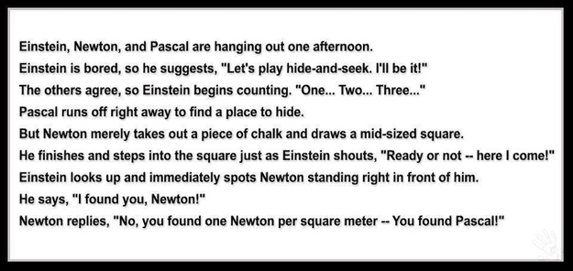

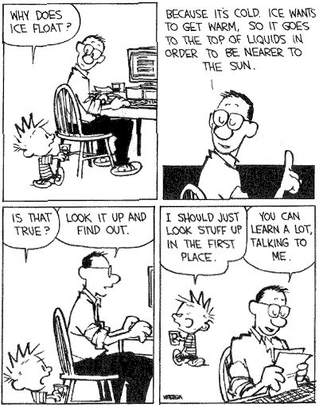

**Pressure in a fluid: the pressure in a fluid increases with depth**

**Demonstration**

Set up as shown.

The water coming out of the bottom hole travels the farthest, because it is under the greatest pressure.

**Applications**

* **Hydrometers**: Used to measure the density of liquids
* **The Bends**: Due to nitrogen in our blood coming out of solution when the pressure drops quickly, and forming little gas bubbles, which then travel with the blood, and can end up in various joints causing severe pain or brain damage.

**Pressure differential in a fluid**

The *difference* in pressure (**Δ**P) between two points in a fluid depends upon:

1. the density of the liquid (ρ)
2. acceleration due to gravity (g)
3. the difference in height between the two points (**Δ**h)



**Δ**P = ρg**Δ**h

**Exam Question** [2004]

A can of height 10 cm is submerged in water.

What is the difference in pressure between the top and bottom of the can?

**Solution**

**Change in pressure Δ**P = (ρ)(g)(**Δ**h) = (1000)(9.8)(0.1) = 980 Pa

**Archimedes’ Principle s**tates that when an object is immersed in a fluid, the upthrust it experiences is equal to the weight of the displaced fluid*.



**Demonstration**

In this example a stone which weighs 10 N in air(using a Newton-meter) is immersed in an overflow can which was full to the brim.

**Result**

The stone now weighs 7 N according to the Newton-meter, so the difference in weight (the upthrust) is 3 N.

The weight of the water which was displaced is also 3 N.

**Conclusion**

The upthrust experienced by the stone is equal to the weight of the displaced fluid.

**The Law of Flotation** states that the weight of a floating object is equal to the weight of the fluid it displaces*.

**Boyle’s Law**

**Boyle’s Law s**tates that *at constant temperature*, the volume of a fixed mass of gas is inversely proportional to its pressure*.  
You must remember to include the phrase ‘at constant temperature’.

**Mathematically:**

$$P∝ \frac{1}{V}$$

⇒ $P=k \frac{1}{V}$

⇒ $PV=k$

So if the pressure of a gas goes up, the volume goes down in the same proportion, which we represent mathematically as follows:

$$p_{1}v_{1}= p_{2}v_{2}$$

Most maths questions on this topic are based around this formula

**Mandatory Experiment:** To Verify Boyle’sLaw

**Leaving Cert Physics Syllabus**

|  |  |  |  |
| --- | --- | --- | --- |
| **Content** | **Depth of Treatment** | **Activities** | **STS** |
|  |  |  |  |
| Density and Pressure | Definitions and Units.  Pressure in liquids and gases.  Boyle’s Law | Demonstration of atmospheric pressure, e.g. collapsing can experiment.  Appropriate calculations | Atmospheric pressure and weather.  The “bends” in diving, etc. |
|  | Archimedes’ Principle.  Law of flotation. | Demonstration only. Calculations not required. | Hydrometers. |

Three guys are on a boat and they have four cigarettes, but no lighters or matches or anything to light it with. What do they do?

Answer: They throw one cigarette overboard and the whole boat becomes a cigarette lighter.

Sorry

**VERIFICATION OF BOYLE’S LAW**

**APPARATUS**

Boyles’ Law apparatus (see diagram)

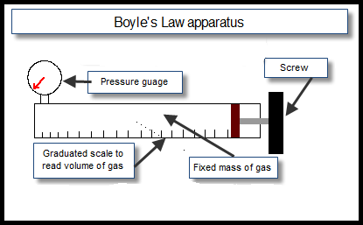**DIAGRAM**

**PROCEDURE**

1. The tube is filled with air.
2. Note the pressure of the gas from the pressure-gauge and the volume from the graduated scale.
3. Turn the screw to decrease the volume and increase the pressure.
4. Note the new readings and repeat to get about seven readings.
5. Draw a graph of pressure against 1/volume. This should result in a straight line through the origin.

**RESULTS**

|  |  |  |  |  |  |  |  |
| --- | --- | --- | --- | --- | --- | --- | --- |
| Pressure (Pa) |  |  |  |  |  |  |  |
| Volume (m3) |  |  |  |  |  |  |  |
| 1/volume (m-3) |  |  |  |  |  |  |  |

**CONCLUSION**

We followed the steps, plotted the graph and did indeed get a straight line through the origin, thus verifying that pressure is inversely proportional to volume.

Whoop-de-doo.

We were just wondering; why do we have to write this up? Why can’t we just put our results into the table as evidence that we did do the actual experiment, then do like the shepherd when he saw the wolves and get the flock out of here?

**PRECAUTIONS / SOURCES OF ERROR**

1. Wait a minute for temperature (and therefore volume) to stabilise after each pressure change before you read the volume.
2. Have your eye level with the pressure gauge when taking readings to avoid parallax error.
3. Work in a room where the temperature remains constant throughout the experiment (I know - I’m clutching at straws here).

**NOTE**

Precaution no. 1 is a load of cobblers because the increase in volume of the air (as a result of the air heating up) is negligible in comparison to the much bigger error associated with taking the readings for pressure and volume. However we continue to include it because it’s what the examiners look for.

**Extra Credit**

**\*Pressure is a scalar quantity**

It is incorrect (although not unusual) to say "the pressure is directed in such or such a direction". The pressure, as a scalar, has no direction. The confusion is often due to the fact that *force* can have a direction associated with it, and therefore is a vector. Pressure however does not have a direction associated with it.

\***Archimedes’ Principle s**tates that when an object is immersed in a fluid, the upthrust it experiences is equal to the weight of the displaced fluid.

Both of these concepts (Archimedes’ Principle and the Law of flotation) should be taken out of the syllabus. They really don’t fit in anywhere and because they are on their own they only cause confusion. But who listens to me?

Sniff ☹

Upthrust: Look at the sphere which is the liquid in the diagram:

There is a force acting downwards – the weight of the body.

Now if the object is not sinking further then there must be another force opposing the first force

(and equal in magnitude).

This force preventing the object from sinking further is called upthrust.

It is due to the fact that the pressure at the top of the object is less than the pressure at the bottom.

**\*The Law of Flotation**

States that the weight of a floating object is equal to the weight of the fluid it displaces*.

To make sense of this it might help to see where it comes from:

Floating object is not accelerating; implies *upward force = downward force*  (1)

i.e. Upthrust = Weight of floating object (2)

But from Archimedes Principle; Upthrust = Weight of displaced fluid (3)

Equating equations (2) and (3) gives us: **Weight of floating object = Weight of fluid displaced.**

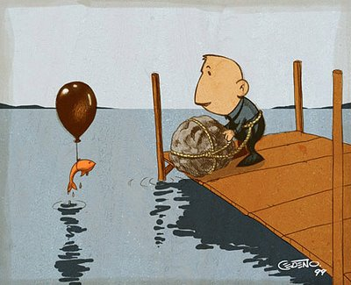

\***Boyle’s Law s**tates that at constant temperature, the volume of a fixed mass of gas is inversely proportional to its pressure.

Here’s a simple activity to demonstrate that pressure affects temperature:

Place the palm of your hand a couple of inches from your mouth, purse your lips and blow; notice how nice and cool it is?

Now do the same thing, except this time ‘haw’ on the hand, i.e. leave your mouth wide open as you expel the air. Notice how much warmer it is.

Now go back to the first stage again, only this time bring your hand right up to your mouth when you blow. This time it seems cool again!

I was going to leave it as an exercise for you to explain how the same air can be at two different temperatures on reaching your hand, but that would be a little disingenuous given that I don’t understand it myself. Obviously it has something to do with pressure, and I think words like ‘adiabatic’ and ‘expansion’ are invoked somewhere along the line, but that’s not an explanation is it?

The point is that pressure, volume and temperature are inexplicably linked, and if you wish to establish a link between any two of them you must keep the third variable constant.

I’ve put up a number of videos on YouTube describing this in more detail. Go to the interactive links page of thephysicsteacher to find them.

**Robert Boyle**

Boyle (from Waterford) was also the first to demonstrate that the sound of a bell in a bell jar faded as the air was removed. This proved that the air was necessary for the transmission of sound.

Besides being a busy natural philosopher, Boyle devoted much time to theology, showing a very decided leaning to the practical side and an indifference to controversial polemics. He founded the Boyle lectures, intended to defend the Christian religion against those he considered "notorious infidels, namely atheists, theists, pagans, Jews and Muslims," with the proviso that controversies between Christians were not to be mentioned.

**Would an astronaut explode in space if they didn’t have a space-suit?**

Provided that you do not hold your breath, exposure to vacuum for 5 to 10 seconds is unlikely to produce permanent injury (although it may cause problems in the eardrum).

Some degree of consciousness would be maintained for up to 15 seconds, which is about the time it takes oxygen-deprived blood to go from the lungs to the brain. During this time, the person exposed to the vacuum may become aware of the water on their tongue beginning to boil. As time progresses injury would accumulate as the evaporation of water vapour causes the body to swell and cool. After four minutes they would finally succumb to asphyxia as the brain cannot survive without oxygen. But they would not explode, thanks to the containing effect of the skin and the circulatory system.

**The bends**

Divers have the opposite challenge to astronauts – how to survive the very high pressures of deep water and then return back to atmospheric pressure at sea level. The gases in the air tanks that divers use to breathe are at high pressure. However, gases that are under high pressure dissolve very easily in water (this is how fizzy drinks are made). This means that if a diver stays in deep water for a long period of time, some of the high pressure nitrogen in the air they are breathing will dissolve in the water in their own body. This becomes a problem if the diver then surfaces too quickly. As the pressure drops the nitrogen comes out of solution and forms painful, and potentially life threatening, bubbles of gas. The only way to avoid getting the bends is to come to the surface slowly, allowing the nitrogen to be released slowly as the pressure gradually decreases.

**Pressure and Boiling Point**

Is it true that you can’t make a decent cup of tea up a mountain?

You might think that mountaineers have other things to worry about other than whether they can get a decent cup of tea, but apparently not. As you ascend a mountain, the air pressure decreases and you find yourself gasping for oxygen as well as a nice cuppa. Unfortunately, as the pressure decreases, liquid water finds it easier and easier to turn into a gas, in other words to boil. At sea level, water boils at 100°C but by the time you’ve reached the top of Everest your kettle will boil at just 72°C.

Which is not nearly hot enough to make a decent cup of tea.

**Things that make you go *Hmmmmmmm* ….**

The Irish scientist Robert Boyle was one of the first to investigate/appreciate atmospheric pressure. He declared that we were all ‘living under a sea of air’.

High pressure is associated with good weather. This is because the ‘blanket of air’ is heavy and it is therefore harder for water molecules to evaporate. There is now less water vapour in the air, so less clouds, which means less rain and more sunlight. So there.

Atmospheric pressure is taken as 100,000 Pa (1 x 105 Pa). Because one Pascal is equivalent to one Newton per square metre, we can say atmospheric pressure is equal to 100,000 Newtons per square metre. Now there are 10,000 square cms in a square metre (100 cm x 100 cm), so therefore *one* square cm of paper will have a force of 10 Newtons (100,000 divided by 10,000) – equivalent to one kilogram - acting down on it from the atmosphere. Or to make it more realistic, if you draw a square, with each side 10 cm long, that gives you an area of 100 squarecm (about the area of the top of your head?), and therefore a force acting downwards (due to atmospheric pressure) of 1,000 Newtons, equivalent to 100 kg. Remember an average student’s weigh would be about 80 kg. And this is acting down on each and every one of us every day!

Apparently we are a couple of cms shorter at night-time than in the morning due to the spine contracting slightly from the weight of our bodies. People who wanted to apply for the Guards, but whose height was borderline, were advised to either get tested in the morning, or lie down during the day until they went for the test!

If you wanted to dive to the bottom of the ocean, you would need to wear a metal suit to prevent getting crushed – see photograph, page 56.

Similarly bottom-dwelling fish could not survive on the ocean surface. Some fish can adapt to the different pressures, but I’m not sure how. Maybe a biology teacher can fill us in?

Aircraft are pressurised, which explains why passengers get ‘sucked out’ of a plane if the door gets blown off at high altitudes.

I recall a quote from Charles Darwin who was describing his extreme discomfort on climbing a particular high-altitude mountain: “I began to bleed through every orifice in my body”.

If a large truck passes you out at speed (if you’re walking or cycling) you can get ‘sucked in’ to its slip-stream.

If you are ever unfortunate enough to be in a car which falls into a lake, and are trying to open the doors, you will not be able to do so until you first let down the window to let in a large amount of water which goes someway to equalising the pressure.

Many liquid containers have two holes which help the liquid to pour out smoothly; one for the liquid out, the other to allow the air to get in without disturbing the flow of liquid. See for example Tetra Pack cartons. Try to empty a two-litre bottle of water and see how long it takes. A much quicker method is to create a ‘mine tornado’ where the air goes up the middle as the water goes down the outside. Quite impressive!

The effect is noticeable if you try to put water into a container which has a small hole on top, like a hot-water bottle! Have you ever tried it? What happens? Would it be any different if you were putting in cold water.See the model of a pair of lungs to demonstrate how we can ‘suck’ up liquids (and air).

**"The Barometer Story"**

Some time ago I received a call from a colleague who asked if I would be the referee on the grading of an examination question. He was about to give a student a zero for his answer to a physics question, while the student claimed he should receive a perfect score and would if the system were not set up against the student. The instructor and the student agreed to submit this to an impartial arbiter, and I was selected.

I went to my colleague's office and read the examination question, "Show how it is possible to determine the height of a tall building with the aid of a barometer."

The student had answered, "Take a barometer to the top of the building, attach a long rope to it, lower the barometer to the street and then bring it up, measuring the length of the rope. The length of the rope is the height of the building."

I pointed out that the student really had a strong case for full credit since he had answered the question completely and correctly. On the other hand, if full credit was given, it could well contribute to a high grade for the student in his physics course. A high grade is supposed to certify competence in physics, but the answer did not confirm this. I suggested that the student have another try at answering the question. I was not surprised that my colleague agreed, but I was surprised that the student did.

I gave the student six minutes to answer the question with the warning that the answer should show some knowledge of physics. At the end of five minutes, he had not written anything. I asked if he wished to give up, but he said no. He had many answers to this problem; he was just thinking of the best one. I excused myself for interrupting him and asked him to please go on. In the next minute he dashed off his answer which read, "Take the barometer to the top of the building and lean over the edge of the roof. Drop that barometer, timing its fall with a stopwatch. Then using the formula *S = ½at²*, calculate the height of the building."

At this point I asked my colleague if he would give up. He conceded, and I gave the student almost full credit.

In leaving my colleague's office, I recalled that the student had said he had many other answers to the problem, so I asked him what they were. "Oh yes," said the student. "There are a great many ways of getting the height of a tall building with a barometer. For example, you could take the barometer out on a sunny day and measure the height of the barometer and the length of its shadow, and the length of the shadow of the building and by the use of a simple proportion, determine the height of the building."

"Fine," I asked. "And the others?"

"Yes," said the student." There is a very basic measurement method that you will like. In this method you take the barometer and begin to walk up the stairs. As you climb the stairs, you mark off the length of the barometer along the wall. You then count the number of marks, and this will give you the height of the building in barometer units. A very direct method."

"Of course, if you want a more sophisticated method, you can tie the barometer to the end of a string, swing it as a pendulum, and determine the value of 'g' at the street level and at the top of the building. From the difference of the two values of 'g' the height of the building can be calculated."

Finally, he concluded, there are many other ways of solving the problem. "Probably the best," he said, "is to take the barometer to the basement and knock on the superintendent's door. When the superintendent answers, you speak to him as follows, 'Mr. Superintendent, here I have a fine barometer. If you tell me the height of this building, I will give you this barometer.'"

At this point I asked the student if he really did know the conventional answer to this question. He admitted that he did, said that he was fed up with high school and college instructors trying to teach him how to think, using the "scientific method"…

**Exam Questions**

1. [2010 OL]

A concrete mixer delivered 50 m3 of concrete to a building site, what was the mass of the concrete delivered?

(Density of concrete = 2400 kg m−3)

1. [2006][2002 OL][2005 OL][2007 OL][2009 OL]

Define pressure.

1. [2002 OL][2005 OL]

Give the unit of pressure.

1. [2006]

Is pressure a vector quantity or a scalar quantity? Justify your answer.

1. [2002 OL][2005 OL]

Name an instrument used to measure pressure.

**Mathematical pressure**

1. [2002 OL]

The wind exerts a horizontal force of 1000 N on a wall of area 20 m2. Calculate the pressure at the wall.

1. [2008 OL]

A solid block in the shape of a cube of length 120 cm rests on a table. The weight of the block is 25 N. Calculate the pressure it exerts on the table.

1. [2005]

A container contains 5.0 kg of water. If the area of the base of the container is 0.5 m2.

Calculate the pressure at the base of the container due to the water.

1. [2005 OL]
2. The African elephant is the largest land animal.

An elephant weighs 40 000 N and is standing on all four feet each of area 0.2 m2.

Calculate the pressure exerted on the ground by the elephant.

1. Why would the pressure on the ground be greater if the elephant stood up on just two feet?
2. [2005 OL][2007 OL]

**Atmospheric Pressure**

Describe an experiment to show that the atmosphere exerts pressure.

1. [2002 OL]

When air is removed from the metal container shown in the diagram, it collapses. Explain why.

1. [2005 OL]

The earth is covered with a layer of air called the atmosphere.

What holds this layer of air close to the earth?

**Pressure in a liquid**

1. [2009 OL]

Describe an experiment to show that the pressure in a liquid increases with depth.

1. [2006 OL]

Which one of the following instruments can be used to measured the density of a liquid?

barometer hydrometer thermometer

1. [2007][2010 OL]

State Archimedes’ principle.

1. [2008]

State the law of flotation.

1. [2004]

A can of height 10 cm is submerged in water. What is the difference in pressure between the top and bottom of the can?

1. [2009 OL]

A diver is swimming at a depth of 5m. He then dives deeper until he reached a depth of 30 m. Calculate the increase in pressure on the diver at this new depth

(p = ρgh ; density of water = 1000 kg m−3 ; g = 9.8 m s−2)

**Boyle’s Law**

1. [2009] [2006][2005][2003 OL][2007 OL] [2010 OL]

State Boyle’s law

1. [2007 OL]
2. A balloon rises through the atmosphere while the temperature remains constant.

The volume of the balloon is 2 m3 at ground level where the pressure is 1000 hPa.

Find the volume of the balloon when it has risen to a height where the atmospheric pressure is 500 hPa.

1. What will happen to the balloon as it continues to rise?
2. [2006]
3. A small bubble of gas rises from the bottom of a lake. The volume of the bubble increases threefold when it reaches the surface of the lake where the atmospheric pressure is 1.01 × 105 Pa. The temperature of the lake is 4 oC. Calculate the pressure at the bottom of the lake.
4. Calculate the depth of the lake.
5. [2004 OL]

**Mandatory Experiment**

In an experiment to verify Boyle’s law, a student measured the volume of a gas at different pressures.

The table shows the measurements recorded by the student.

|  |  |  |  |  |  |  |  |
| --- | --- | --- | --- | --- | --- | --- | --- |
| Pressure /kPa | 100 | 111 | 125 | 143 | 167 | 200 | 250 |
| Volume /cm3 | 5.0 | 4.5 | 4.0 | 3.5 | 3.0 | 2.5 | 2.0 |
| 1/Volume /cm-3 |  |  | 0.25 |  |  |  |  |

1. Draw a labelled diagram of the apparatus used in this experiment.
2. Copy this table and fill in the last row by calculating 1/ volume for each measurement.
3. Plot a graph on graph paper of pressure against 1/volume.
4. Explain how your graph verifies Boyle’s law.
5. Give one precaution that the student took in carrying out the experiment.
6. [2003]

In an experiment to verify Boyle’s law, a student measured the volume *V* of a gas at different values of the pressure *p*.

The mass of the gas was not allowed to change and its temperature was kept constant.

The table shows the data recorded by the student.

|  |  |  |  |  |  |  |  |
| --- | --- | --- | --- | --- | --- | --- | --- |
| *p/* kPa | 120 | 180 | 220 | 280 | 320 | 380 | 440 |
| *V*/cm3 | 9.0 | 6.0 | 5.0 | 4.0 | 3.5 | 3.0 | 2.5 |

1. Describe with the aid of a diagram how the student obtained this data.
2. Draw a suitable graph on graph paper to show the relationship between the pressure of the gas and its volume.
3. Explain how your graph verifies Boyle’s law.
4. Describe how the student ensured that the temperature of the gas was kept constant.

**Exam Solutions**

1. m = 2400 × 50 = 120000 kg
2. Pressure = Force ÷ area.
3. The unit of pressure is the pascal.
4. It is a scalar because it has no direction.
5. The barometer.

**Mathematical pressure**

1. P = F/A = 1000/20 = 50 Pascals.
2. P = F/A  P = 25 ÷ (1.2)2  P = 17.4 pa
3. P = F/A = [ (5.0)(9.8)/(0.5)]  P = 98 Pa
4. P = F/A ⇒ P = 40 000/0.8 ⇒ P = 5,000 Pa.
5. The area would be smaller.

**Atmospheric Pressure**

1. Apparatus: glass of water and cardboard.

Procedure: place cardboard over glass and invert.

Observation/conclusion: water remains in glass.

1. The pressure outside (due to atmospheric pressure) is greater than the pressure inside.
2. Gravity.



**Pressure in a liquid**

1. Set up as shown.

Note that the water coming out of the hole at the bottom travels the farthest because it is under the greatest pressure.

1. Answer: hydrometer
2. When an object is immersed in a fluid, the upthrust it experiences is equal to the weight of the displaced fluid.
3. When a body floats in a liquid its weight is equals the weight of fluid displaced.
4. P = ρgh  P = (1000)(9.8)(0.1) = 980 Pa
5. Pressure at 30 m: (p = ρgh = (103)(9.8)(30) =) 2.94 ×105 Pa

Pressure at 5 m: (p = ρgh = (103)(9.8)(5) =) 0.49 ×105 Pa

Increase in pressure at 30 m: =2.94 ×105 – 0.49 ×105 = 2.45 ×105 Pa

**Boyle’s Law**

1. Boyle’s Law states that Pressure is inversely proportional to volume for a fixed mass of gas at constant temperature.
2. 
3. (P1V1 = P2V2) ⇒ 1000 × 2 = 500 × V2. ⇒ V2 = (1000 × 2)/500 = 4 m3.
4. It will continue to expand
5. Pressure at bottom = 3 × pressure at top = 3.03 × 105 Pa)
6. Ridiculously tricky one this; you need to consider just the effect of the water so to get rid of the effect of the atmosphere you must ignore the 1.01 × 105 Pa (the pressure of the atmosphere).

Pressure at bottom due to water = 2.02 × 105 Pa

P= ρgh

h = P/ρg = 2.02 × 105 / (1.0 × 103)( 9.8 ) = 20.61 m

**Mandatory Experiment**

1. See diagram.
2. See table

|  |  |  |  |  |  |  |  |
| --- | --- | --- | --- | --- | --- | --- | --- |
| Pressure /kPa | 100 | 111 | 125 | 143 | 167 | 200 | 250 |
| Volume /cm3 | 5.0 | 4.5 | 4.0 | 3.5 | 3.0 | 2.5 | 2.0 |
| 1/Volume /cm-3 | 0.20 | 0.22 | 0.25 | 0.28 | 0.33 | 0.40 | 0.50 |

1. See graph
2. A straight line through the origin shows that pressure is proportional to 1/volume
3. After changing pressure wait a short time before taking readings / read the volume scale at eye level.
4. See diagram.

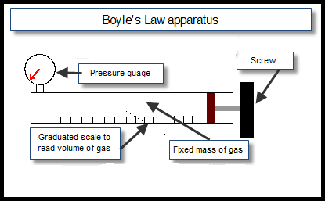Note the pressure of the gas from the pressure-gauge and the volume from the graduated scale.

Turn the screw to decrease the volume and increase the pressure.

Note the new readings and repeat to get about seven readings.

|  |  |  |  |  |  |  |  |
| --- | --- | --- | --- | --- | --- | --- | --- |
| *p/* kPa | 120 | 180 | 220 | 280 | 320 | 380 | 440 |
| *1/V*/cm-3 | 0.111 | 0.167 | 0.200 | 0.250 | 0.286 | 0.333 | 0.400 |

Axes labelled

6 points plotted correctly

Straight line

Good fit

1. A straight line through the origin verifies that pressure is inversely proportional to volume
2. Release the gas pressure slowly, allow time between readings.

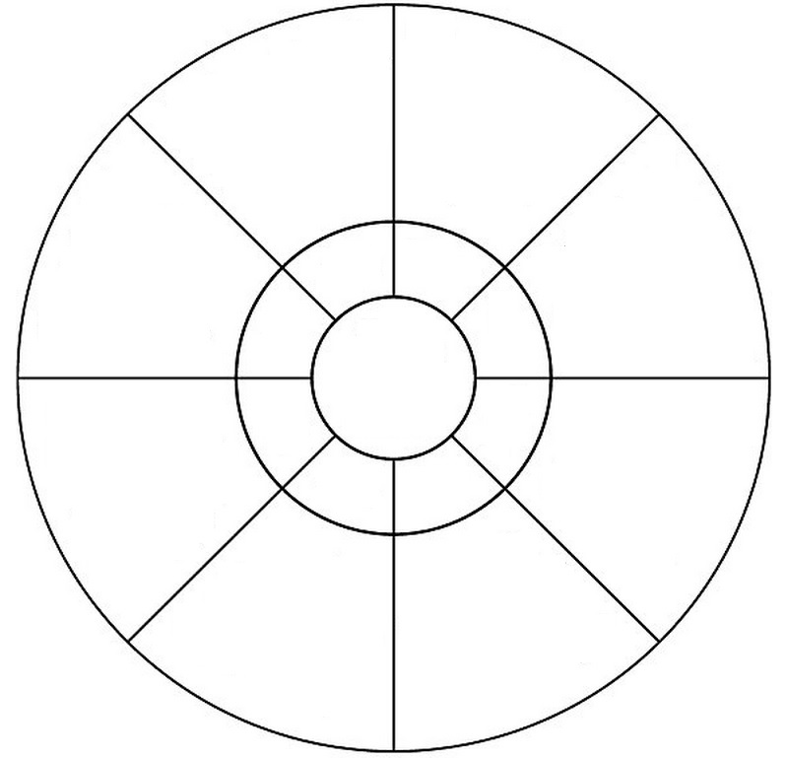Topic: ________________________

Key words

Name: Date:

**Fun activities**

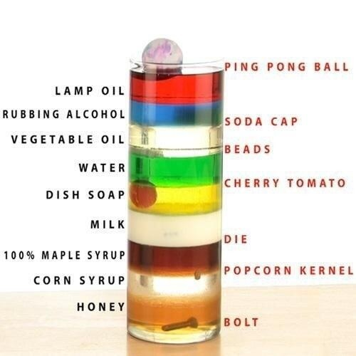

**Other simple density demonstrations**

Try to float an orange in a beaker of water – predict what will happen

Peel the orange and repeat – predict what will happen.

Why is the result different?

Place a regular coke can and a diet coke can in a basin of water.

Predict what will happen first.

Why is the result different?

Get a glass of seven-up.

Drop in some raisins.

Wait.

Note that the raisins rise and fall.

Why?

**Air**

**Air has mass**

1. Weigh an empty plastic bottle (with the top on) and note the mass.
2. Pump air into it using a special pump and weigh it again. Note the new mass.
3. Result: there was an increase in mass as a result of pumping air in, therefore air has mass.

**Air takes up space**

1. Tape some cotton wool to the (inside) bottom of a small glass.
2. Turn the glass upside down, submerge it completely into a large bowl of water and then remove it again.
3. Predict what will happen:

Try to explain what you saw:

**Or**

1. Place a table tennis ball on top of the water and now submerge the upside-down glass with the table-tennis ball.
2. Predict what will happen:

Try to explain what you saw:

**Or**

1. Place a table-tennis ball half-way into a gas-jar (which is lying on its side) and use a straw to blow the table-tennis ball to the back of the jar.
2. Predict what will happen:

Try to explain what you saw:

**Or**

1. Place a table-tennis ball half-way into a gas-jar (which is standing up) and use a straw to blow on the table-tennis ball.
2. Predict what will happen:

Now try to explain what you saw:

**Atmosphere Pressure**

The atmosphere is about 32 km deep and is made up of giggling atoms which are continually bumping against each other and any surface they come in contact with.

Imagine we took an angry wasp and put him in a plastic sandwich bag which was sealed on top; there would be a lot of collisions with the inside wall of the bag – yes?

Now let’s imagine we had *one* *million* angry wasps and shrank them so that they were all able to fit into the bag and still have room to fly about. There would be so many collisions with the inside surface that the bag would seem to magically inflate.

Now imagine we place that bag in a room where we have lots of other wasps.   
In fact there are so many wasps outside that there are twice as many in every cubic centimeter as there are inside the sandwich bag.

What happens the sandwich bag?

Well twice as many wasps per cubic centimeter means there will be twice as many collisions with the bag per second from the outside as there would be from the inside. So the bag would get smaller.

This is similar to what we have with air, except the critters doing all the colliding aren’t wasps – they are air molecules (molecules of nitrogen, oxygen, carbon dioxide, water vapor etc).

We refer to the all the catmospheric pressure.

No wasps were harmed in the making of this analogy.

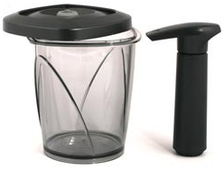

**Demonstration**

Place some marshmallows / partially inflated balloons / shaving cream into the container (it’s actually for keeping coffee beans fresh).

Use the hand pump to pump out some of the air.

What will happen?

Why?  
What difference, if any, is there between what happens the balloon compared to the marshmallows?

**Some variations**

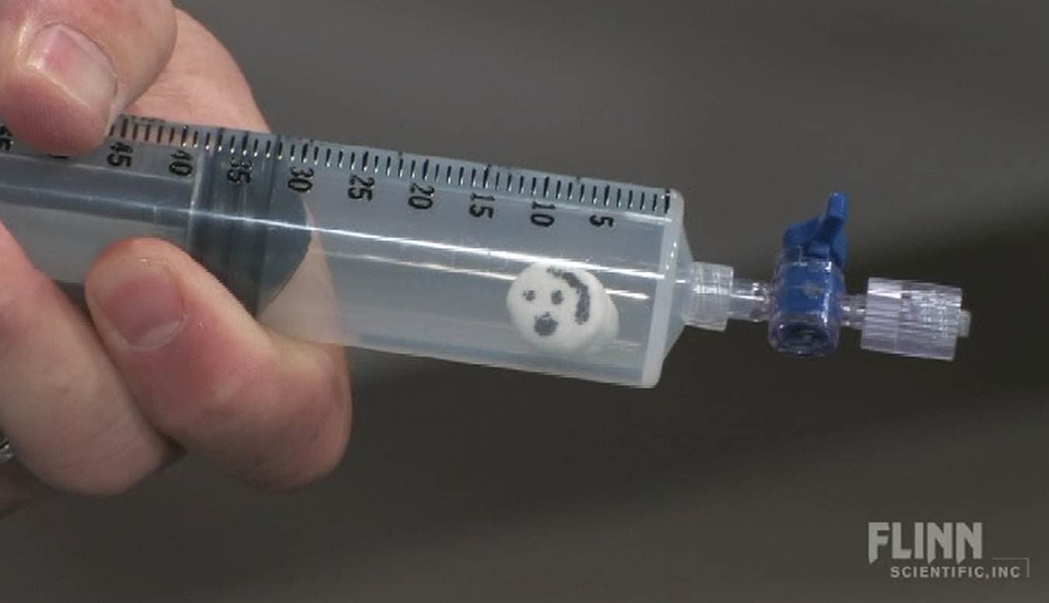

**Demonstration**

Get an empty coke can and pour in a little water.

Boil the water over a hot plate so that the water vapour (steam) is gushing out.

Quickly turn the can upside down and immerse it in a basin of cold water.

What will happen?

Why?

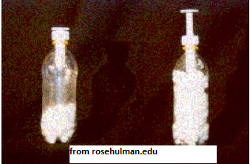**Demonstration *- feel* atmospheric pressure**

Vacuum pack a student.   
Now you know how the coke can feels!!

**Demonstration *- feel* atmospheric pressure**

Lay a CD under a sheet with a piece of string tied to it and running up through the sheet - give a slight tug.

What will happen?

Why?

**Demonstration**

Balance a wooden ruler so that half of it hangs over the edge of a bench.  
Cover the over half with a sheet of newspaper (you need a broadsheet newspaper to guarantee it works.)  
Use a karate chop on the over-hanging piece of the ruler.  
What will happen?

Why?

**Demonstration – large scale**

Use a large metal drum and pump the air out using a vacuum pump.

The drum will collapse (implode) because there is now a greater pressure outside acting inwards than there is inside acting outwards.

See something similar happen to massive train carriages on YouTube.

**Another nice demonstration on the effects expanding air – the exploding film canister**

Put a piece of Alka-Slezter into the canister.

Pour a small amount of water into the canister

Place the lid on and lay the canister on its side.

Wait!

**The effect of pressure on the boiling point of water**

**Reduced pressure decreases the boiling point of water**

**Demonstration**

1. 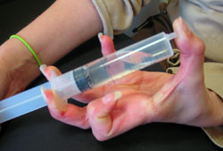Suck up water which is at about 80 0C into a syringe so that the syringe is about one-quarter full.
2. Cover the open end (watch out - it’s hot!) and pull back the handle to create a partial vacuum.

Observation: The water begins to boil!

**Explanation**

1. The air acts like a blanket which presses down on the water and makes it difficult for the water molecules to leave (‘jump out of’) the liquid and become part of the air.
2. Reduced pressure therefore results in a lower boiling point (the molecules don’t need as much energy (move as rapidly) to make the transition from water to water vapour.

Note: you could also use the coffee apparatus above to demonstrate this; place some water in a small beaker and place this in the container – the boiling is even more impressive. Give the inside of the container a wipe of shaving foam to reduce condensation.